**AI AND IOT TECHNOLOGY IN AUTOMOTIVE PARTS MANUFACTURING**

## ****Introduction****

This project aims to optimize **automotive parts manufacturing** using **AI-driven predictive analytics**. The system will use **AI models** to analyze production data and **Power BI for visualization**, helping manufacturers improve efficiency, reduce defects, and minimize downtime.

## Data Flow Diagram

## 

**User Inputs Data**:

* Data is **collected manually** by operators
* Inputs include **sensor readings, production stats, maintenance logs, and quality control data.**

**Stored in Database:**

* The system **stores data** in a **structured format**
* The database ensures **data integrity and accessibility** for AI analysis.

**AI Model Processes Data:**

* The AI model analyzes stored data to extract **patterns, predict failures, and recommend optimizations.**
* Uses **Machine Learning & Deep Learning models** like:

1. **Regression models** for predictive maintenance.
2. **Classification models** for defect detection.
3. **CNN-based image recognition** for quality control.

**Insights Sent to Power BI:**

* Once processed, AI-generated insights are **formatted and transferred to Power BI** for visualization.
* Insights help managers **monitor performance and take quick decisions.**

**Dashboard Generates Reports:**

* Power BI **creates interactive dashboards** to present insights in a **user-friendly manner.**
* The dashboard **displays key metrics** using graphs, charts, and heatmaps.

**User Views Analytics & Takes Action:**

* The factory manager or technician **reviews the dashboard reports** and makes **data-driven decisions.**
* Based on insights, they take **corrective and preventive actions.**

**UML Diagram**

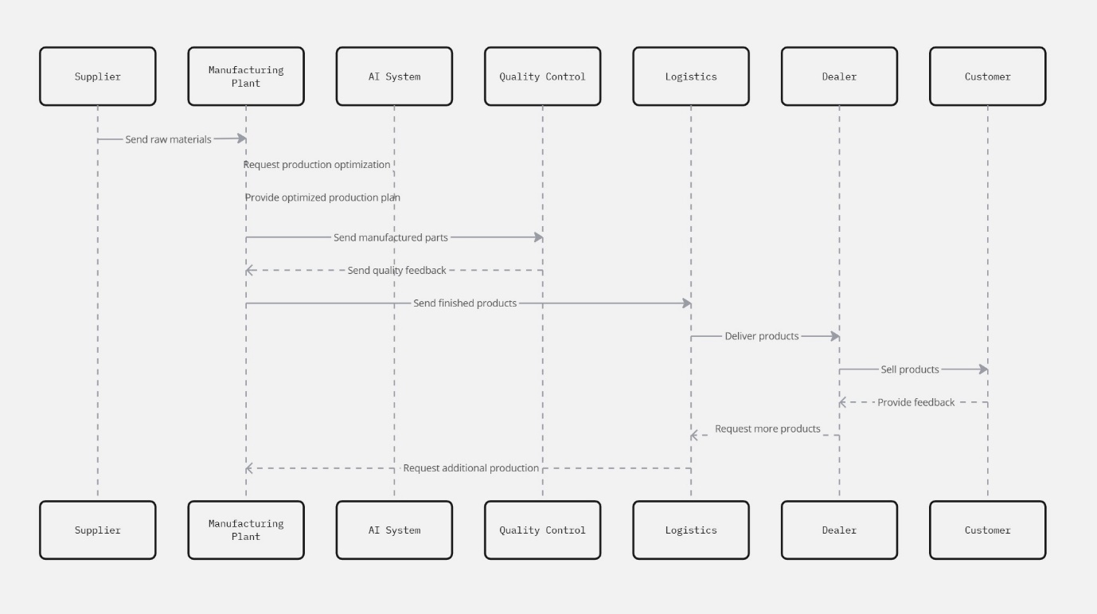

**Supplier → Manufacturing Plant**

* The supplier sends raw materials to the manufacturing plant based on demand and inventory levels.
* The AI system can predict material requirements and optimize procurement to prevent shortages or overstocking.

**Manufacturing Plant → AI System**

* The manufacturing plant requests production optimization from the AI system based on incoming orders, raw material availability, and machine capacity.
* The AI analyzes real-time data to optimize production schedules, reduce waste, and maximize efficiency.

**AI System → Manufacturing Plant**

* The AI system provides an optimized production plan based on historical data, demand forecasting, and machine learning models.
* The AI ensures minimal delays and smooth production workflow by suggesting optimal batch sizes and timelines.

**Manufacturing Plant → Quality Control**

* Once the parts are manufactured, they are sent to the Quality Control department for inspection and testing.
* AI-driven quality control can automate defect detection using computer vision and sensor data analysis.

**Quality Control → Manufacturing Plant**

* If quality issues are detected, feedback is sent to the manufacturing plant for corrective actions or re-manufacturing.
* The AI system can track recurring defects and suggest improvements to minimize errors in future production.

**Manufacturing Plant → Logistics**

* After passing quality checks, finished products are sent to the logistics team for distribution.
* AI assists in route optimization, vehicle scheduling, and inventory tracking to ensure efficient delivery.

**Logistics → Dealer**

* The logistics team delivers products to dealers according to optimized schedules and demand forecasts.
* AI helps predict dealer demand and ensure inventory levels are balanced across different locations.

**Dealer → Customer**

* The dealer sells the products to end customers.
* AI-driven recommendations can improve customer targeting and sales strategies.

**Customer → Dealer**

* Customers provide feedback on product quality and performance.
* AI analyzes feedback to detect trends and improve future product quality.

**Dealer → Logistics**

* If demand increases, the dealer requests additional products from logistics to restock inventory.
* AI predicts restocking needs based on sales data and automates reorder processes.

**Manufacturing Plant → Supplier**

* If more raw materials are required due to increased demand, the manufacturing plant requests additional materials from the supplier.
* AI automates procurement planning, reducing delays and ensuring seamless production.